**DETAILS FOR 3X3 MATRIX PIPELINED MULTIPLICATION:**

|  |  |  |  |  |  |  |  |  |  |  |  |
| --- | --- | --- | --- | --- | --- | --- | --- | --- | --- | --- | --- |
| Clock Cycles | 1cc | 2cc | 3cc | 4cc | 5cc | 6cc | 7cc | 8cc | 9cc | 10cc | 11cc |
| 1ST ROW ,1ST COLUMN | Fetch+ multiply | Add | Store |  |  |  |  |  |  |  |  |
| 1ST ROW ,2nd COLUMN |  | Fetch+ multiply | Add | Store |  |  |  |  |  |  |  |
| 1ST ROW ,3rd COLUMN |  |  | Fetch+ multiply | add | Store |  |  |  |  |  |  |
| 2nd ROW ,1st COLUMN |  |  |  | Fetch+ multiply | add | Store |  |  |  |  |  |
| 2nd ROW , 2nd COLUMN |  |  |  |  | Fetch+ multiply | add | Store |  |  |  |  |
| 2nd ROW ,3rd COLUMN |  |  |  |  |  | Fetch+ multiply | add | Store |  |  |  |
| 3rd ROW ,1st COLUMN |  |  |  |  |  |  | Fetch+ multiply | add | Store |  |  |
| 3rd ROW ,2nd COLUMN |  |  |  |  |  |  |  | Fetch+ multiply | add | Store |  |
| 3rd ROW ,3rd COLUMN |  |  |  |  |  |  |  |  | Fetch+ multiply | add | store |

**SIMULATION:**

**STAGE: 1 FETCH + MULTIPLY**

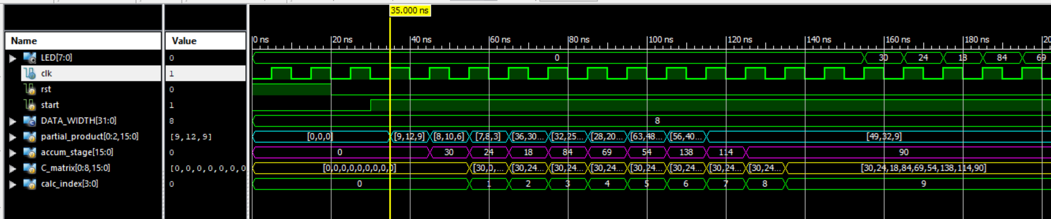

**STAGE: 2 (FETCH + MULTIPLY) + ADD**

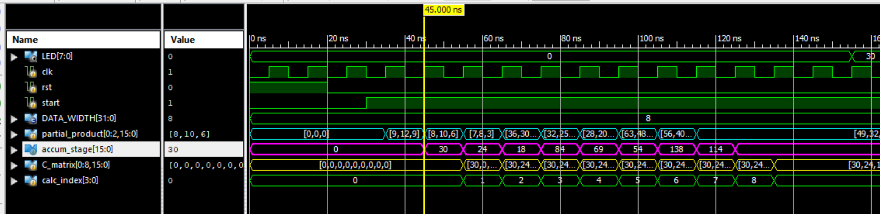

**STAGE: 3 (FETCH+MULTIPLY) + ADD + STORE**

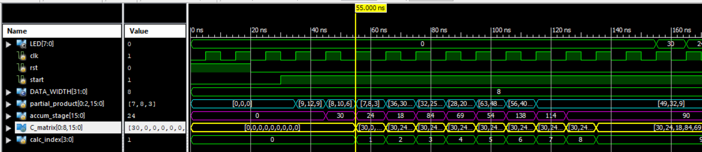

**AT 11CC 3X3 MATRIX FULL RESULT:**

